COMP 2019 Workbook Exercises Week 3 – Heuristic SearchSpecify in which order the states of the following graph would be expanded under each of the  
specified search strategies, starting in state A. Assume states are expanded in alphabetical order if  
there are multiple states to choose. The edge labels denote the true costs of moving between  
adjacent states. The goal is to find state L.

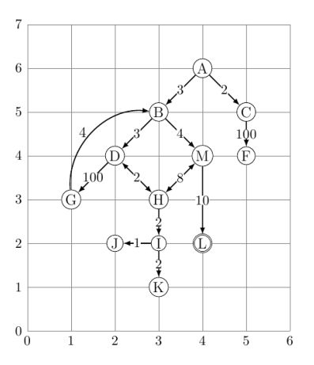  
1) Choose a consistent heuristic function for A\* suitable to the above search problem.

Manhattan Distance  
2) Calculate the estimated distances from states A,B,G to the goal state L.

AL = 4, BL = 4, GL = 4, CL = 4, DL = 4, FL = 3, HL = 2, IL = 1, JL = 2, KL = 2, LL = 0, ML = 2  
3) Which path from A to L will A\* find using the chosen heuristic function? ABML  
In each step of the algorithm, state g(N), h(N), f(N), the Open and Closed lists, and which  
state is selected for expansion.  
4) How many states will A\* expand in the best and worst case (independent of the chosen  
heuristic function)?  
5) What would be the perfect heuristic function? Why is it usually infeasible to construct it?  
6) Which search strategy do you obtain if h(N)=0 for all N?  
7) Given two consistent heuristic functions h1(N) and h2(N)=h1(N)+1 (for N not a goal state).  
Which heuristic will lead to A\* expanding fewer nodes?